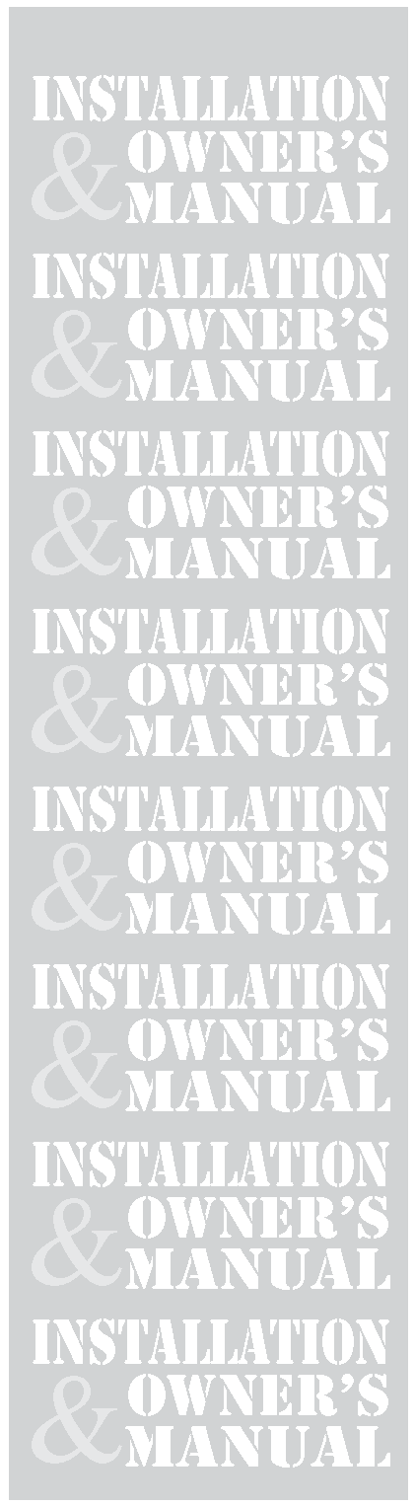

SMART RELAY
Rev. 1.00 (11/30/12)

SMART RELAY CONTROL PANEL

Model #:_______ Serial #______________________

Start-Up Date: _______________________

Harsco Industrial, Patterson-Kelley
100 Burson Street
East Stroudsburg, PA 18301
Telephone: 570.476.7261
Toll Free: 877.728.5351
Facsimile: 570.476.7247
www.harscopk.com

1 Introduction 3
2 Safety 3
2.1 General 3
2.2 Training 3
2.3 Safety Features 3
2.4 Safety Labels 3
2.5 Safety Precautions 4
3 Installation 5
3.1 Receiving and Storage 5
3.2 Compliance with Codes 5
3.3 Setup 6
3.4 Electrical Connections 6
3.5 Gas Piping 9
3.6 Boiler Water Piping 10
3.7 Pre-Start Check List 11
3.8 Safety Checks 11
3.9 Initial Adjustments 11
3.10 Fuel/Air Adjustment 13
4 Operation 14
4.1 General 14
4.2 Normal Lighting and Shut-Down Procedures 14
4.3 Emergency Shut-Off 15
4.4 Typical Boiler Operating Conditions 15
5 Maintenance 16
5.1 Maintenance and Inspection Schedule 16
5.2 Cleaning the Burner 17
5.3 After All Repairs or Maintenance 17
5.4 Sequence of Operation 18
5.5 Troubleshooting 19
6 Parts/Technical Support 20
6.1 Wiring Diagrams 20

 It is essential to read, understand, and follow the recommendations of this manual before installing, operating, or servicing this equipment.

Installation and service must be performed by a qualified and knowledgeable individual who has been trained on Harsco Industrial, Patterson-Kelley MACH® boilers.

Introduction

LOREM IPSUM

Safety

General
The Smart Relay Control Panel must be:

- Installed, operated, and serviced in accordance with instructions contained in this manual and other supplemental manuals.
- Installed by qualified personnel in accordance with designs prepared by qualified facility engineers including: mechanical, electrical, and other applicable disciplines.
- Operated and serviced in accordance with a comprehensive safety program determined and established by the customer. Do not attempt to operate or service until such a program has been established.
- Operated and serviced by experienced, qualified, and properly trained personnel in accordance with all applicable codes, laws, and regulations.

Training
Proper training is the best protection against accidents.
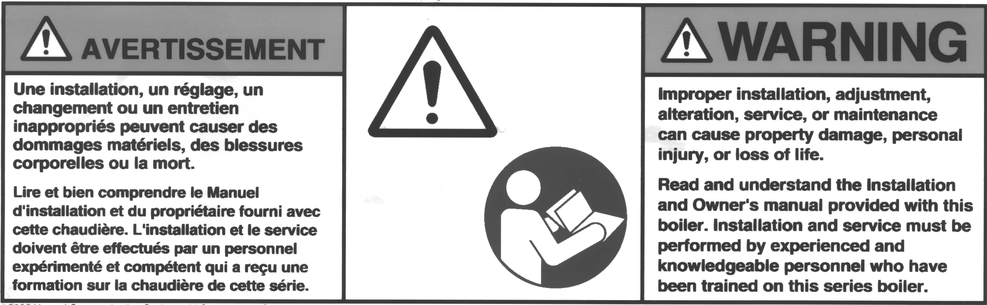
It is essential to read, understand, and follow the recommendations of this manual before installing, operating, or servicing this equipment. Failure to do so could result in fire or explosion and serious injury, death, and/or property damage.

Operating and service personnel must be thoroughly familiar with the basic construction of the MACH® C3000 and C4000 boilers, the use and locations of the controls, the operation of the boilers, adjustment of their various mechanisms, and all applicable safety precautions. If any of the provisions of this manual are not fully and completely understood, contact the Harsco Industrial, Patterson-Kelley Technical Service at 570.476.7261 or toll free at 877.728.5351.

Safety Features
It is the responsibility of the customer to maintain the safety features, such as but not limited to: guards, safety labels, safety controls, interlocks, lockout devices, in place and operable.

Safety Labels
The following words are used in this manual to de-note the degree of seriousness of the individual hazards.
 indicates an imminently hazardous situation which, if not avoided, will result in death or serious injury. This signal word is to be limited to the most extreme situations.
indicates a potentially hazardous situation which, if not avoided, could result in death or serious injury.
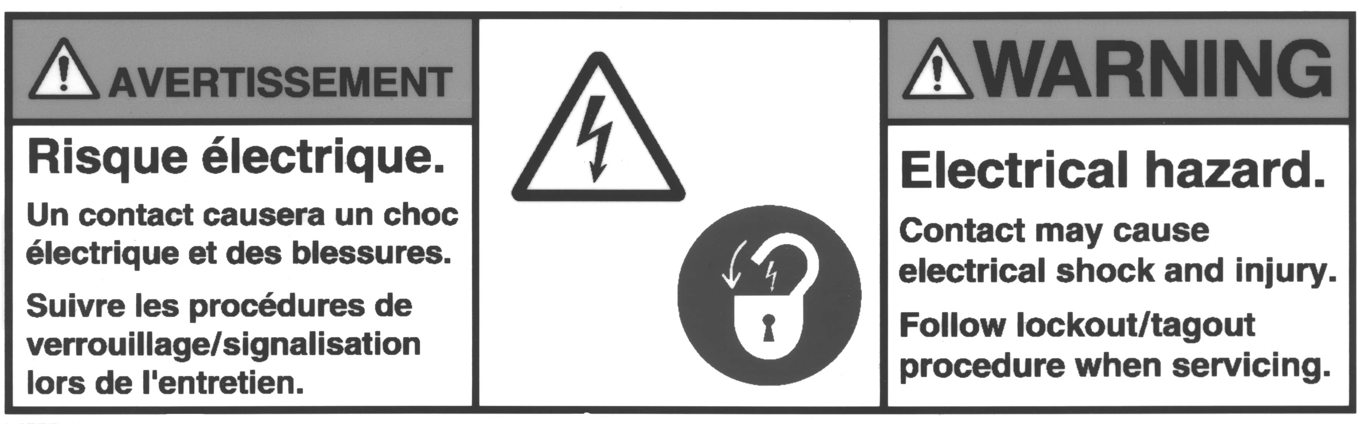
 indicates a potentially hazardous situation which, if not avoided, may result in minor or moderate injury. It may also be used to alert against unsafe practices.
NOTICE/NOTE - NOTICE is the preferred signal word to address practices not related to personal injury. The safety alert symbol is not used with this signal word.

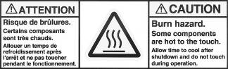

The safety labels shown above are affixed to your boiler. Although the labels are of high quality, they may become dislodged or unreadable over time. Contact Harsco Industrial, Patterson-Kelley at 570.476.7261 or toll-free at 877.728.5351 for replacement labels.

Safety Precautions
Provide a suitable location for the boiler, away from normal personnel traffic, with adequate working space, adequate clearances, proper ventilation and lighting, with a structure sufficiently strong and rigid to support the weight of the boiler, all piping, and accessories.

Electrical Hazards
- Shock hazard! Properly lockout/tagout the electrical service and all other energy sources before working on or near the boiler.
- Shock hazard! Do not spray water directly on this boiler or on any electrical components.
- Electrical hazard! Do not alter wiring connections.

Installation
Installation and service must be performed by a qualified installer, service agency, or gas supplier.

LOREM IPSUM

Receiving and Storage

Initial Inspection
Upon receiving the boiler, inspect it for signs of shipping damage. Since some damage may be hidden, unpack the boiler, open the front, and side doors and inspect the boiler. Verify that the total number of pieces shown on the packing slip agrees with those actually received.
NOTICE! Note any damage, suspected potential damage, or shortage of materials on the freight bill and immediately notify the carrier. File all claims for shortage or damage with the carrier. Claims for hidden damages must be filed with your carrier within 7 days. The boiler carton is equipped with a “Tip (N) Tell”. If "Tip (N) Tell” arrow point is blue, that indicates that the package has been on its side or tipped over in transit.

Storage Prior to Installation
If the boiler is not installed immediately, it must be stored in a location adequately protected from the weather, preferably indoors. If this is not possible, then it should remain in the shipping container and be covered by a tarpaulin or other waterproof covering.
NOTICE! Controls and other equipment that are damaged or fail due to weather exposure are not covered by warranty.

Compliance with Codes
The MACH® boiler with standard components and with many options complies with American National Standard/CSA Standard ANSI Z21.13/CSA 4.9, latest edition, Gas-Fired Low Pressure Steam and Hot Water Boilers.
The heat exchanger is constructed and stamped in accordance with ASME Boiler and Pressure Vessel Code, Section IV for 125 psig maximum operating pressure.
Installation of the boiler must conform to all the requirements of all national, state and local codes established by the authorities having jurisdiction or, in the absence of such requirements, to the National Fuel Gas Code, ANSI Z223.1/NFPA 54 latest edition in the U.S. In Canada, the equipment shall be installed in accordance with the current Installation Code for Gas Burning Appliances and Equipment, CAN/CSA-B.149, latest edition, and applicable Provincial Regulations for the class, which should be carefully followed in all cases. Authorities having jurisdiction should be consulted before installations are made.
Where required by local codes, the installation must conform to American Society of Mechanical Engineers Safety Code for Controls and Safety Devices for Automatically Fired Boilers (ASME CSD-1).
In the Commonwealth of Massachusetts (a) this unit must be installed by a licensed pipe fitter / plumber, (b) field installed gas cocks must be “T” handle type, (c) piping of condensate shall conform to the State Plumbing Code, and (d) refer to the Massachusetts Supplement for further details.

Setup

Foundation and Placement
Provide a firm, level foundation, preferably of concrete.
The wheels provided with this boiler are for positioning purposes only. When positioning this boiler, maintain positive control of it at all times. Do not attempt to move the boiler on surfaces that are not level. Failure to heed this warning could result in personal injury or death.

Lifting the front of the boiler slightly will allow the boiler to be rolled off the shipping skid onto the concrete foundation. Once in position, the wheel bolts may be removed allowing the wheels to recess up into the boiler. The base will sit flat on the provided foundation. If the boiler is to be pulled out for maintenance, the wheels may be left attached.

Placement
The boiler must be level to function properly. There are six 9/16” holes in the base that may be used for 3/8” seismic anchors.
NOTICE! The boiler may be installed on a combustible floor; however, the boiler must never be installed on carpeting.

Clearances
If the boiler is to be installed near combustible surfaces, the minimum clearances shown in the pictures and table below must be maintained. Failure to provide for the service access clearances, even with non-combustible surfaces, may cause future problems servicing the boiler. Maintain a clearance from the vent to combustible surfaces of 18” or as specified in the vent manufacturer’s listed installation instructions. The boiler must be installed in a space large in comparison to the boiler as described in the National Fuel Gas Code, ANSI Z223.1, latest edition.

Electrical Connections
The MACH© C3000 boiler requires 208-240 volts, three phase, 60 hertz electrical service.
Be sure to check the nameplate on the boiler before connecting electrical supply.
The total operating amperage is indicated on the rating nameplate. Each MACH® C3000 or C4000 boiler requires less than 20 Amps. Before starting the boiler, check to ensure that the proper electrical service is connected to the boiler.
An external electrical disconnect (not supplied with the boiler) is required. The boiler electrical service must be installed and grounded in accordance with local codes or in the absence of such requirements, in the U.S. with National Electrical Codes, ANSI/NFPA No. 70 latest edition or, in Canada, to the Canadian Electrical Code, Part I, CSA C22.1, latest edition. Installed conduit must not block openings and must allow the side doors to be opened.

NOTICE! A dedicated earth ground (green wire) is required to avoid nuisance shutdowns. Do not ground through the conduit.

The electrical junction boxes are located at the front sides of the boiler. There are two on the left (top and bottom) and one on the right.

Power Input Junction Box

High Voltage (TB2) Terminal Block
The high voltage (TB2) terminal block is for 120VAC output loads only. Do not connect any 120VAC supply voltage to the high voltage (TB2) terminal block. Connecting a 120VAC supply voltage to TB2 can result in serious injury or death.

120 VAC Neutral- These terminals provide the neutral wires for the boiler 120 VAC outputs.

120VAC Switched Output- This contact closes when the boiler is switched on. This provides 120 VAC, 0.5 Amp service to TB2-10. The neutral for this circuit is provided on TB2-3. When the boiler is switched off, this terminal is switched off as well.

Low Voltage (TB1) Terminal Block
Enable/Disable– TB1-1 and TB1-2 are used for enabling the boiler. Closing this circuit allows the boiler to run. Opening this circuit prevents the boiler from running. This circuit is energized by the boiler. It has a 24 VAC potential. Devices connected to these terminals must be rated for 24 VAC
External Interlock – TB1-3 and TB1-4 are used for attachment of an additional field safety device to the boiler control circuit. Closing this circuit allows the boiler to run. Opening this circuit prevents the boiler from running. This circuit is energized by the boiler with a 5 V potential. Devices connected to these terminals must be rated for 5 V.

Removing an Existing Boiler
(from a common venting system)
When an existing boiler is removed from a common venting system, the common venting system is likely to be too large for proper venting of the appliances remaining connected to it.
At the time of removal of an existing boiler, while the other appliances remaining connected to the common venting system are not in operation, the following steps should be followed with each appliance remaining connected to the common venting system placed in operation:
1. Seal any unused openings in the common venting system.
2. Visually inspect the venting system for proper size and horizontal pitch and determine that there is no blockage or restriction, leakage, corrosion or other deficiency which could cause an unsafe condition.
3. Insofar as is practical, close all building doors and windows and all doors between the space in which the appliances remaining connected to the common venting system are located and other spaces of the building. Turn on clothes dryers and any appliances not connected to the common venting system. Turn on any exhaust fans, such as range hoods and bathroom exhausts, so they will operate at maximum speed. Do not operate a summer exhaust fan. Close fireplace dampers.
4. Place the appliance being inspected in operation. Follow the lighting instructions. Adjust the thermostat so that the appliance will operate continuously.
5. Test for spillage at the draft hood relief opening after 5 minutes of main burner operation. Use the flame of a match or candle or smoke from a cigarette, cigar or pipe.
6. After it has been determined that each appliance remaining connected to the common venting system properly vents when tested as outlined above, return doors, windows, exhaust fans, fireplace dampers and any other gas-burning appliance to their previous conditions of use.
Any improper operation of the common venting system should be corrected so the installation conforms to the National Fuel Gas Code, ANSI Z223.1 and CSA B149 Installation Code. When resizing any portion of the common venting system, the common vent system should be resized to approach the minimum size as determined using the appropriate tables in part 11 of the National Fuel Gas Code, ANSI Z223.1/NFPA 54 and/or CAN/CSA B149.1 Natural Gas and Propane Installation Code.

Operation

General

Control Panel Front
Become familiar with the basic operation of the boiler. The interior of the front door shows the boiler Operating Instructions.

Factory Tests
Safe lighting and other performance criteria were met with the gas manifold and control assembly provided on this boiler when the boiler underwent factory tests specified in ANSI Z21.13/CSA 4.9, latest edition. (See "Factory Firetest" label.)

Normal Lighting and Shut-Down Procedures
Do not use this boiler if any part has been under water. Immediately call a qualified service technician to inspect the boiler and to replace any part of the control system and any gas control which has been under water.

Lighting Procedures
- Make sure the system is filled with water and water is circulating in the system. Turn on electrical supply and open the gas supply valves to the boiler.
- Turn the on/off switch to the on position. If an error is indicated, see Section 5.5 of this manual to troubleshoot the problem and take the necessary corrective action before proceeding.
- Set the desired high temperature limit and operating temperature. The controller will now complete the automatic firing sequence.

Normal Shut Down Procedures
1. Close all manual gas valves.
2. Turn off electric power.

Emergency Shut-Off

Typical Boiler Operating Conditions
Model Number | Input Rating (BTU/Hr) | Voltage (three phase) | Total Amperage | Gas Flow Rate (CFH)
 |  |  |  | Natural Gas  1030  Btu/cu. ft. | LP Gas  2500 Btu/cu. ft. | Output Capacity (Btu/hr)
C3000 | 3,000,000 | 208-240 | Less than 20 | 2913 | 1200 | 2,850,000
C4000 | 4,000,000 | 208-240 | Less than 20 | 3689 | 1520 | 3,800,000
 |  | 440-480 | Less than 20

NOTICE! The heat exchanger is constructed and stamped for 100 psig maximum operating pressure and 220 º F maximum temperature.

Maintenance

Maintenance and Inspection Schedule
This schedule applies when the boiler is in use. Verify proper operation after servicing.

Proper lockout/ tagout procedure must be employed when servicing this unit.
Label all wires prior to disconnection when servicing controls. Wiring errors can cause improper and dangerous operation.
Use care when reassembling main gas line to assure all connections are tight.
Use care when servicing boiler in order to prevent the accumulation of gas in or around the combustion chamber.
Determine the cause of any lockout or errors before resetting the boiler. If able to determine cause of lockout, then appropriate corrective action should be taken. If unable to determine cause of the problem, call a qualified service technician. Verify proper operation after servicing.

Daily
Observe operating temperature and general conditions. Make sure that the flow of combustion and ventilating air to the boiler is not obstructed. Determine the cause of any service codes or lockouts on the display panel. Observe any unusual noises or operating conditions and make the necessary corrections. Notify responsible individuals for required corrective action or repair.

Check daily to be sure that the boiler area is free and clear of any combustible materials, including flammable vapors and liquids.

Weekly
Observe the conditions of the main flame. A normal high fire flame is mostly orange with a blue halo, while at low fire the burner will glow yellowish-orange.

Monthly
1. Using the control panel, enter the information mode and scroll down view the flame signal. This is measured in micro-amps of flame conductivity.
2. Test high-limit Control. Refer to Section 3.9.3.
3. Test operating temperature controls by reducing or increasing temperature setting as necessary to check burner operation.
4. Test the low water level cut-out. Refer to Section 3.9.2.
5. Test low gas pressure switch. Refer to Section 3.9.4.

Annually
In addition to the recommended monthly and semi-annual service:
- Inspect and clean the inlet screen of any accumulated dust or lint.
- Check burner and clean off any soot or foreign material that may have accumulated. See Section 5.2 on "Cleaning the Burner." Check for corrosion of the burner and its parts. If there is evidence of deterioration or corrosion, replace immediately. Inspect combustion chamber when the burner is removed for inspection. Note any signs of deterioration. Clean as necessary.
- Inspect and clean heat exchanger. Remove the various covers to inspect the flue gas passageways. Clean the combustion side casting pins by flushing with clean water and blowing dry with compressed air. Do not use any cleaning agents or solvents. Do not use soap. A soft nylon brush may be used in accessible areas. Be sure to inspect the condensate collection pan that is the lowest part of the heat exchanger.
- Replace the igniter and gasket.
- Drain and flush the water side of the heat exchanger as required (separate from system flush) using clean water only.
- Inspect and clean the condensate system and check for leaks. If a condensate neutralization kit is present, open the lid and inspect the limestone rocks. If they are absent or have been significantly worn away, replace them with new limestone rocks. Use hi-calcium (or pure) limestone.
- Examine the venting system at least once a year. Refer to the vent manufacturer's instructions for requirements in addition to those listed below.
  - Check all joints and pipe connections for tightness.
  - Check pipe for corrosion or deterioration. If any piping needs replacing, do so immediately.
  - Inspect and clean any screens in the vent terminal
- Qualified service personnel should thoroughly inspect the heating system and correct any problems prior to re-starting the boiler.
- Perform combustion analysis and readjust as necessary according to table 3-1 and section 3.10.4. It is recommended that a copy of this report is filed for future reference.
- Perform a leak test of the gas valves in accordance with the manufacturer's instructions.
- Test pressure safety relief valve.
Installation and service must be performed by a qualified installer or service agency that has been trained on the Harsco Industrial, Patterson-Kelley MACH® boiler.

Cleaning the Burner

- Lockout/tagout gas supply to the boiler.
- Lockout/tagout electrical power to the boiler.
- Open the front and side doors of the boiler.
- Locate the blower and burner transition pieces that are directly in the front of the boiler. See 6.2.4 for illustration of components.
- Remove the 8 nuts & 2 bolts connecting the blower transition piece to the burner transition piece. The blower Removing the Heat Exchanger

After All Repairs or Maintenance
1. Follow "Pre-Start Check List" (Section 3.8) and all "Safety Checks" (Section 3.9).
2. Check gas pressure. (Section 3.11.2.1). Ensure proper operation of unit
3. Perform combustion check. Adjust gas flow if necessary. (Section 3.11.2..2).

Sequence of Operation

NORMAL OPERATION:
- When first powered on, the Smart Relay Control Panel will drive one valve fully-open and the remaining valve(s) fully-closed.
- When a boiler receives a call for heat, the ENVI controls will provide a 120VAC signal through the CIRC PUMP CONTACTOR (TB2-6 and TB2-16).
- The Smart Relay Control Panel receives this 120VAC signal, and energizes the applicable VALVE OPEN relay (120VAC).
- The applicable valve actuator drives its valve open.
- Once the valve reaches the fully-open position, the end limit switch located on the valve actuator closes the VALVE END SWITCH circuit.
- When the Smart Relay Control Panel receives closure of the VALVE END SWITCH, it will energize the BOILER INTERLOCK relay. This closes the boiler’s external interlock (TB1-3 and TB1-4) which allows the boiler to begin its pre-purge sequence.
- Repeat steps 2 – 6 repeat until all boilers installed on the system are online.
- When the call for heat is removed and the boiler completes its post-purge sequence, the CIRC PUMP CONTACTOR signal is lost.
- The Smart Relay Control Panel de-energizes the BOILER INTERLOCK and VALVE OPEN relays. It then energizes the applicable VALVE CLOSE relay (120VAC).
- The applicable valve actuator drives its valve closed.
- The end limit switch opens the VALVE END SWITCH circuit.
- Repeat steps 8 – 11 until only one boiler is online.
- When only one boiler remains online and its call for heat is removed and the boiler completes its post-purge sequence, the CIRC PUMP CONTACTOR signal is lost.
- The Smart Relay Control Panel de-energizes the BOILER INTERLOCK relay. It continues to energize the applicable VALVE OPEN relay.

MANUAL OVERRIDE MODE:

- When the MANUAL OVERRIDE switch is toggled to the ON position, the Smart Relay Control Panel will energize each VALVE OPEN relay.
- Each valve actuator drives its valve open.
- Once each valve reaches the fully-open position, each end limit switch located on the valve actuators close the VALVE END SWITCH circuit.
- The Smart Relay Control Panel will energize each BOILER INTERLOCK relay. This allows any or all of the boilers to light off with the valve in the fully-open position.

Troubleshooting

If any “Manual Reset” limit device trips, DO NOT reset without determining and correcting the cause. (Manual Reset Limits include: Flame safeguard, high or low gas pressure, high temperature limit, stack temperature, low water level.)

ABCDEF
ABCDEF.

“A07 LOW FLOW / ILK” Error
asdf

Boilers Won’t Ignite
The Smart Relay is designed to operate in conjunction with an end limit switch located on the valve actuator. When the valve is in the fully-open position, the end limit switch on the actuator will close. This signals to the Smart Relay that the valve is open and it is acceptable for the boiler to ignite. The Smart Relay then closes the Remote Interlock on the boiler, which should allow it to begin its prepurge and ignition sequence.
If the ENVI display constantly reads “Checking Flow / ILK” then the Remote Interlock is not closed when the boiler has a call for heat. If the Remote Interlock does not close within five minutes of a call for heat, the ENVI controls will indicate an “A07 LOW FLOW / ILK” error which will require a manual reset.
- Flip the “MANUAL OVERRIDE” switch to the ON position. This should drive all the boiler valves to the fully-open position and close the boiler’s Remote Interlock.
- Inspect the End Switch wiring between the valve actuator and the Smart Relay Control Panel. Ensure each termination is secured and the wires aren’t frayed, torn, split or stripped.
- Inspect the Drive Open wiring between the valve actuator and the Smart Relay Control Panel. Ensure each termination is secured and the wires aren’t frayed, torn, split or stripped.
- Inspect the Remote Interlock wiring between the boiler and the Smart Relay Control Panel. Ensure each termination is secured and the wires aren’t frayed, torn, split or stripped.
- Ensure the Remote Interlock wiring is located in its own conduit or in a conduit which only houses low-voltage wiring. Running both low-voltage and high-voltage wiring in the same conduit can cause electromagnetic induction which will cause unwanted voltages in the Remote Interlock wiring.
- Inspect the end limit switch on the valve actuator. The switch mechanism that signals when the valve is in the fully-open position may be stuck, disengaged, or worn. If this switch mechanism does not close properly when the valve is in the fully-open position, the Smart Relay will not close the Remote Interlock on the boiler. If the actuator is driving the valve to the fully-open position, use a MultiMeter to check continuity on the end limit switch. If there is no continuity when the valve is fully-open, the End Limit Switch will need to be replaced.
- Look at the Drive Open relay inside the Smart Relay Control Panel. If the Smart Relay is attempting to drive a valve open, the amber light on the Drive Open relay should be illuminated. If this light is dark, it may be time to replace this relay.

- Inspect the valve actuator. If the amber light on the Drive Open relay inside the Control Panel is illuminated but the actuator is not driving the
- Look at the Remote Interlock relay inside the Smart Relay Control Panel. If the Smart Relay Control Panel is attempting to close a boiler’s interlock, the amber light on the Remote Interlock Relay should be illuminated. If this light is dark, it may be time to replace this relay.

Parts/Technical Support
Spare parts and replacement parts can be ordered from Harsco Industrial, Patterson-Kelley by calling toll free (877) 728-5351. The fax number is (570) 476-7247. Technical information is also available at the above number and at the Harsco Industrial, Patterson-Kelly website www.harscopk.com.
Use of Non-Factory Authorized replacement parts are not recommended for this equipment. All control components are engineered for safety and are designed to work in unison with each of the other components. Use of non-factory authorized replacement parts jeopardizes the functionality of the safety features as well as the performance of the boiler.
When ordering replacement parts please have the order number of your boiler system available. Typical schematic drawings are shown on the following pages. Drawings specific to your particular boiler can also be supplied by your local Harsco Industrial, Patterson-Kelley representative.

Wiring Diagrams

Terminal Block Assignments – Power Block
Terminal Label | Purpose
L | 120 VAC (Hot)
N | 120 VAC (Neutral)
G | Ground

Terminal Block Assignments – 2 Boiler Model
INPUTS
Terminal Label | External Connection | Description
104 | S1 (B1 Valve) | B1 Valve End Switch (120 VAC)
105 | S3 (B1 Valve) | B1 Valve End Switch (120 VAC)
109 | S1 (B2 Valve) | B2 Valve End Switch (120 VAC)
110 | S3 (B2 Valve) | B2 Valve End Switch (120 VAC)
111 | TB2-13 (B1 Pump) | B1 Circulation Pump Relay (120 VAC)
112 | TB2-6 (B1 Pump) | B1 Circulation Pump Relay (120 VAC)
113 | TB2-13 (B2 Pump) | B2 Circulation Pump Relay (120 VAC)
114 | TB2-6 (B2 Pump) | B2 Circulation Pump Relay (120 VAC)
23 | TB2-15 (B1 Alarm) | B1 24 VAC Master Alarm Relay – H
24 | TB2-16 (B1 Alarm) | B1 24 VAC Master Alarm Relay - N
25 | TB2-15 (B2 Alarm) | B2 24 VAC Master Alarm Relay – H
26 | TB2-16 (B2 Alarm) | B2 24 VAC Master Alarm Relay - N

OUTPUTS
Terminal Label | External Connection | Description
101 | 2 (B1 Valve) | B1 Valve Drive Open (120 VAC)
102 | 1 (B1 Valve) | B1 Valve Common
103 | 3 (B1 Valve) | B1 Valve Drive Close (120 VAC)
106 | 2 (B2 Valve) | B1 Valve Drive Open (120 VAC)
107 | 1 (B2 Valve) | B1 Valve Common
108 | 3 (B2 Valve) | B1 Valve Drive Close (120 VAC)
15 | TB1-3 (B1 Interlock) | B1 External Interlock (Dry)
16 | TB1-4 (B1 Interlock) | B1 External Interlock (Dry)
17 | TB1-3 (B2 Interlock) | B2 External Interlock (Dry)
18 | TB1-4 (B2 Interlock) | B2 External Interlock (Dry)
19 |  | B1 Master Alarm Relay (Dry)
20 |  | B1 Master Alarm Relay (Dry)
21 |  | B2 Master Alarm Relay (Dry)
22 |  | B2 Master Alarm Relay (Dry)

Terminal Block Assignments – 4 Boiler Model

2 Boiler Smart Relay Wiring Diagram

4 Boiler Smart Relay Wiring Diagram
TB1

